(Germanium)

Tabell 1 Sambandet ström - spänningen vid konstant temperatur (KISEL)

V (V) | I (nA)
0.27 | 2000000
0.26 | 1610000
0.25 | 1360000
0.24 | 1120000
0.23 | 911000
0.22 | 730000
0.21 | 578000
0.20 | 452000
0.19 | 399000
0.18 | 265000
0.17 | 199000
0.16 | 148000
0.15 | 108000
0.14 | 78800
0.13 | 57100
0.12 | 40800
0.11 | 28800
0.10 | 20300
0.09 | 14150
0.08 | 9890
0.07 | 6720
0.06 | 4530
0.05 | 3020
0.04 | 1920
0.03 | 1150
0.02 | 626
0.01 | 258

V (mV) | I (nA) | I/I_{o} | ln(I/I₀)
0,000 | 0,0000 | 0,0000000 | 0,00000000
90,056 | 0,0011 | 3,5450000 | 1,26550000
120,128 | 0,0039 | 8,9090900 | 2,18700000
150,135 | 0,0098 | 19,9090000 | 2,99110000
180,467 | 0,0219 | 42,5454000 | 3,75057000
210,144 | 0,0468 | 90,8181000 | 4,50886000
240,370 | 0,0999 | 190,7272720 | 5,25084400
270,130 | 0,2098 | 407,9090900 | 6,01104000
300,010 | 0,4487 | 892,4545450 | 6,79397000
330,170 | 0,9817 | 2012,7272700 | 7,60720000
360,520 | 2,2140 | 4649,0909090 | 8,44440000
390,280 | 5,1140 | 11313,6360000 | 9,33370000
420,360 | 12,4450 | 29227,2700000 | 10,28280000
450,460 | 32,1500 | 79272,7272000 | 11,28060000
480,110 | 87,2000 | 22090,9091000 | 12,34187000
510,000 | 252,0000 | 666727,2727000 | 13,41013600
540,800 | 733,4000 | 2035454,5450000 | 14,52600000
570,190 | 2239,0000 | 5883636,3640000 | 15,58768000
600,070 | 6472,0000 | 18554545,4500000 | 16,73622000
630,070 | 20410,0000 | 89445454,5500000 | 18,30913900
670,070 | 983900,0000 | 27000000,0000000 | 19,42863866
700,400 | 301400,0000 | 778727272,7000000 | 20,47317000
730,220 | 856600,0000 | 1809090909,0000000 | 21,31609030
760,000 | 1990000,0000 | 1809090909,0909100 | 21,31609030

I₀=0.0011 nA

Tabell 2 Framströmmens temperaturberoende vid konstant framspänningen (KISEL)

I (nA) | V-termo (mV) | T (K) | I/I₀ | ln(I/I_{o}) | 1/T
0,015 | 0,70 | 114,0000 | 1,0000 | 0,000000000000 | 0,008771930
0,022 | 0,80 | 119,0000 | 1,4667 | 0,382992252256 | 0,008403361
0,035 | 0,90 | 123,0000 | 2,3333 | 0,847297860387 | 0,008130081
0,051 | 1,00 | 128,0000 | 3,4000 | 1,223775431622 | 0,007812500
0,085 | 1,10 | 132,0000 | 5,6755 | 1,736152791998 | 0,007575758
0,120 | 1,20 | 137,0000 | 8,0000 | 2,079441541680 | 0,007299270
0,190 | 1,30 | 141,0000 | 12,6667 | 2,538973871058 | 0,007092199
0,280 | 1,40 | 145,0000 | 18,6667 | 2,926739402067 | 0,006896552
0,410 | 1,50 | 149,0000 | 27,3333 | 3,308106958596 | 0,006711409
0,570 | 1,60 | 153,0000 | 38,0000 | 3,637586159726 | 0,006535948
0,800 | 1,70 | 157,0000 | 53,3333 | 3,976561526566 | 0,006369427
1,120 | 1,80 | 160,0000 | 74,6667 | 4,313033763187 | 0,006250000
1,540 | 1,90 | 164,0000 | 102,6667 | 4,631487494305 | 0,006097561
2,080 | 2,00 | 168,0000 | 138,6667 | 4,932072971593 | 0,005952381
3,700 | 2,20 | 175,0000 | 246,6667 | 5,508037897530 | 0,005714286
6,440 | 2,40 | 182,0000 | 429,3333 | 6,062233617996 | 0,005494505
10,510 | 2,60 | 188,0000 | 700,6667 | 6,552032262769 | 0,005319149
16,700 | 28,00 | 195,0000 | 1113,3333 | 7,015113797303 | 0,005128205
26,510 | 30,00 | 201,0000 | 1767,3333 | 7,477227098181 | 0,004975124
41,650 | 3,20 | 208,0000 | 2776,6667 | 7,929006446493 | 0,004807692
66,740 | 3,40 | 214,0000 | 4449,3333 | 8,400509551203 | 0,004672897
107,730 | 3,60 | 220,0000 | 7182,0000 | 8,879333174786 | 0,004545455
175,920 | 3,80 | 226,0000 | 11728,0000 | 9,369734424126 | 0,004424779
297,300 | 4,00 | 231,0000 | 19820,0000 | 9,894446807884 | 0,004329004
1235,000 | 4,50 | 246,0000 | 82333,3333 | 11,318531326942 | 0,004065041
3671,000 | 5,00 | 259,0000 | 244733,3333 | 12,407924461377 | 0,003861004
10251,000 | 5,50 | 272,0000 | 683400,0000 | 13,434835618663 | 0,003676471
31510,000 | 6,00 | 285,0000 | 2100666,6667 | 14,557765312631 | 0,003508772
49500,000 | 6,20 | 290,0000 | 3300000,0000 | 15,009433026437 | 0,003448276
66600,000  I₀=0.015 nA | 6,60 | 300,0000 | 4440000,0000 | 15,306164934408 | 0,003333333

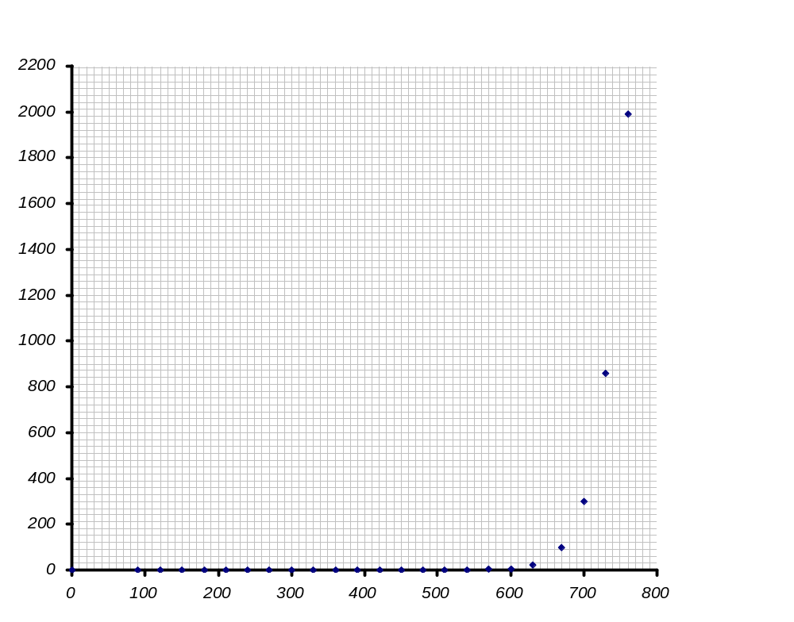
I (nA)
V_{a} (mV)

Sambandet ström - spänningen vid konstant temperatur

(KISEL)
Diagram 1

Sambandet ström - spänningen vid konstant temperatur
presenterad i linlog diagram
(KISEL)
In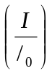
Område ”H”
Diagram 1a
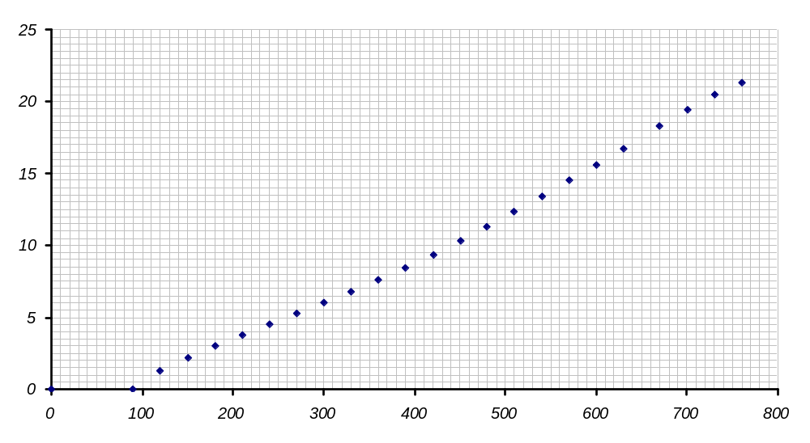
m₁
m₂
V (mV)
V_{a}
V_{diod}
Område ”L”

Framströmmens temperaturberoende vid konstant framspänningen (KISEL)
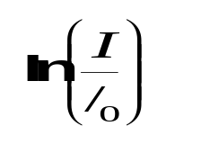
Diagram 2
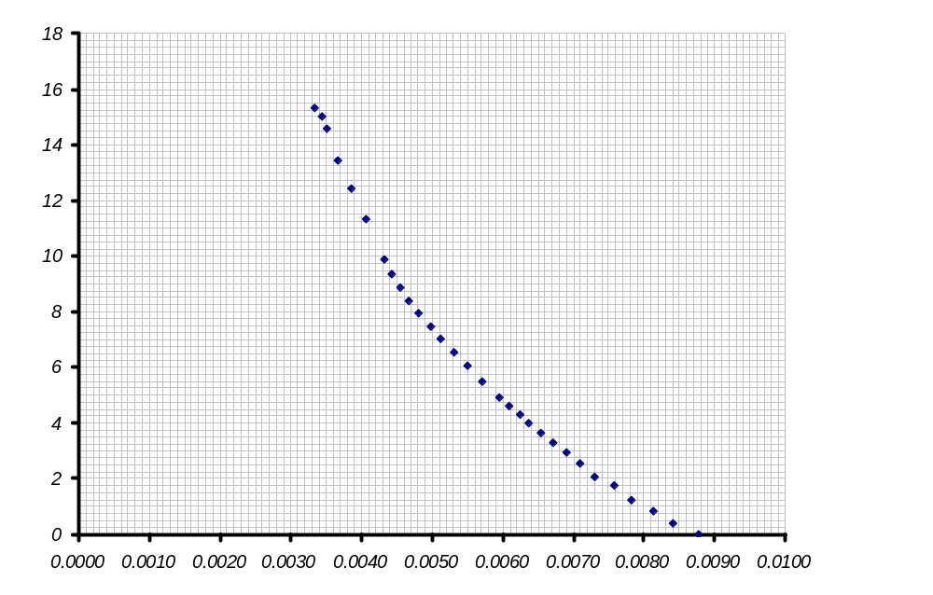
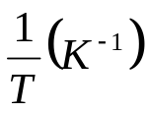
Lutningen = k₁= 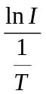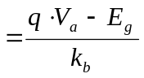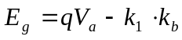

Samband mellan kapacitans och spänning

(KISEL)
Diagram 3
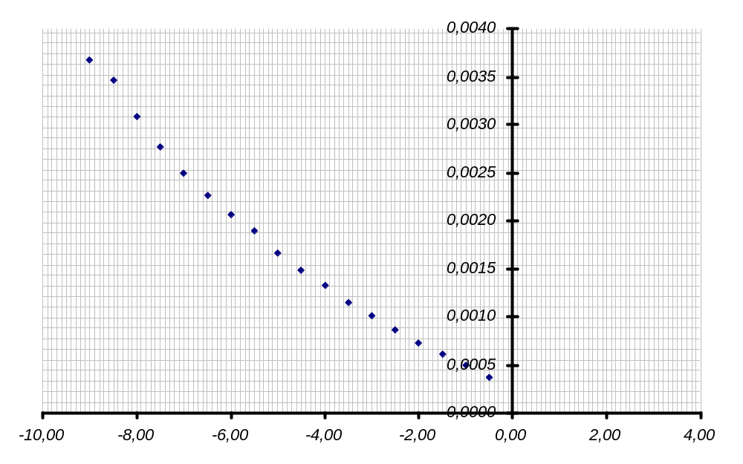
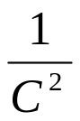
V_{a} (V)
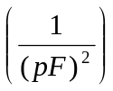
Lutningen = k₂= 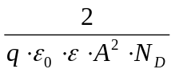

V_{bi}≈0,85 V

Tabell 3 Sambandet kapacitans - spänningen (KISEL)

V (V) | C (pF) | 1/C^2
-0.50 | 52.0 | 0.0003698225
-1.00 | 45.0 | 0.0004938272
-1.50 | 40.5 | 0.0006096632
-2.00 | 37.0 | 0.0007304602
-2.50 | 34.0 | 0.0008650519
-3.00 | 31.5 | 0.0010078105
-3.50 | 29.5 | 0.0011490951
-4.00 | 27.5 | 0.0013223140
-4.50 | 26.0 | 0.0014792899
-5.00 | 24.5 | 0.0016659725
-5.50 | 23.0 | 0.0018903592
-6.00 | 22.0 | 0.0020661157
-6.50 | 21.0 | 0.0022675737
-7.00 | 20.0 | 0.0025000000
-7.50 | 19.0 | 0.0027700831
-8.00 | 18.0 | 0.0030864198
-8.50 | 17.0 | 0.0034602076
-9.00 | 16.5 | 0.0036730946
-9.50 | 15.5 | 0.0041623309
-10.00 | 15.0 | 0.0044444444

Framströmmens temperaturberoende vid konstant framspänningen (Germanium)
Diagram 2a
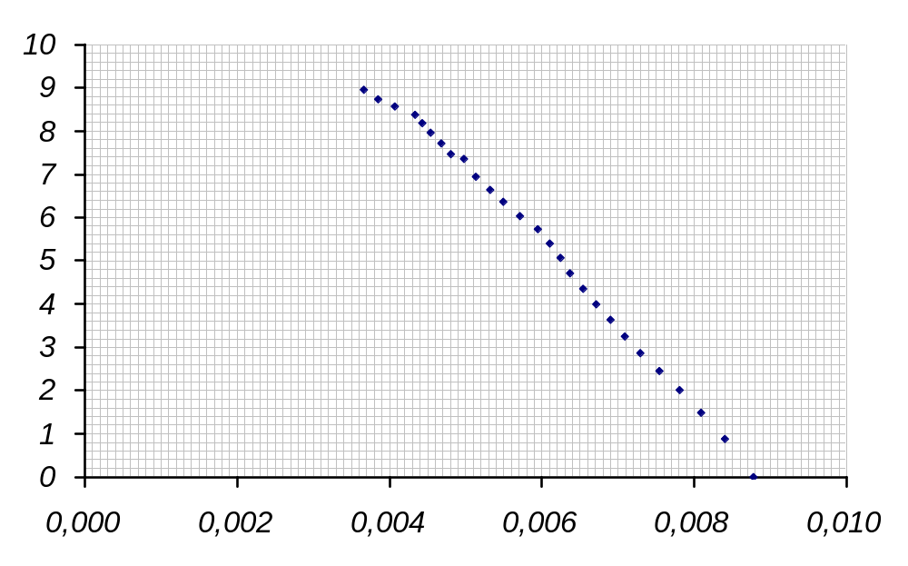
Lutningen = k_{1a}= 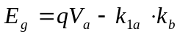

Framströmmens temperaturberoende vid konstant framspänningen

Tabell 2a
(Germanium)

V (mV) | I (uA) | V /mV | T /K | I/I* | ln(I/I*) | 1/T (1/K)
10 | 0,2580 | 0,70 | 114,0 | 1,000000000 | 0,000000000 | 0,008771930
20 | 0,6260 | 0,80 | 119,0 | 2,426356589 | 0,886390786 | 0,008403361
30 | 1,1500 | 0,90 | 123,5 | 4,457364341 | 1,494557636 | 0,008097166
40 | 1,9200 | 1,00 | 128,0 | 7,441860465 | 2,007120880 | 0,007812500
50 | 3,0200 | 1,10 | 132,5 | 11,70542636 | 2,460052525 | 0,007547170
60 | 4,5300 | 1,20 | 137,0 | 17,55813953 | 2,865517634 | 0,007299270
70 | 6,7200 | 1,30 | 141,0 | 26,04651163 | 3,259883849 | 0,007092199
80 | 9,8900 | 1,40 | 145,0 | 38,33333333 | 3,646319840 | 0,006896552
90 | 14,1500 | 1,50 | 149,0 | 54,84496124 | 4,004510318 | 0,006711409
100 | 20,3000 | 1,60 | 153,0 | 78,68217054 | 4,365416580 | 0,006535948
110 | 28,8000 | 1,70 | 157,0 | 111,6279070 | 4,715171081 | 0,006369427
120 | 40,8000 | 1,80 | 160,0 | 158,1395349 | 5,063477775 | 0,006250000
130 | 57,1000 | 1,90 | 164,0 | 221,3178295 | 5,399599811 | 0,006097561
140 | 78,8000 | 2,00 | 168,0 | 305,4263566 | 5,721708691 | 0,005952381
150 | 108,0000 | 2,20 | 175,0 | 418,6046512 | 6,036926921 | 0,005714286
160 | 148,0000 | 2,40 | 182,0 | 573,6434109 | 6,352007968 | 0,005494505
170 | 199,0000 | 2,60 | 188,0 | 771,3178295 | 6,648100519 | 0,005319149
180 | 265,0000 | 2,80 | 195,0 | 1027,131783 | 6,934525520 | 0,005128205
190 | 399,0000 | 3,00 | 201,0 | 1546,511628 | 7,343757111 | 0,004975124
200 | 452,0000 | 3,20 | 208,0 | 1751,937984 | 7,468477874 | 0,004807692
210 | 578,0000 | 3,40 | 214,0 | 2240,310078 | 7,714369563 | 0,004672897
220 | 730,0000 | 3,60 | 220,0 | 2829,457364 | 7,947840228 | 0,004545455
230 | 911,0000 | 3,80 | 226,0 | 3531,007752 | 8,169338591 | 0,004424779
240 | 1120,0000 | 4,00 | 231,0 | 4341,085271 | 8,375879658 | 0,004329004
250 | 1360,0000 | 4,50 | 246,0 | 5271,317829 | 8,570035673 | 0,004065041
260 | 1610,0000 | 5,00 | 259,5 | 6240,310078 | 8,738785152 | 0,003853565
270 | 2000,0000 | 5,50 | 272,5 | 7751,937984 | 8,955698154 | 0,003669725

Diagram 1c

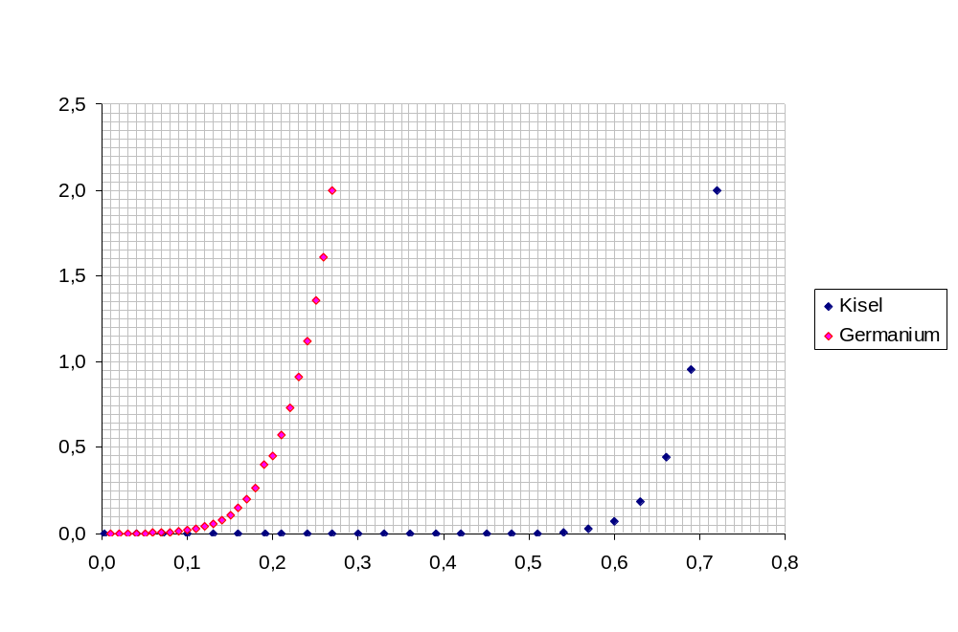
V_{a} =0,28 V
(Germanium)
V_{a} =0,74 V
(Kisel)
V (V)

Sambandet ström - spänningen vid konstant temperatur

(KISEL och Germanium)

